GVH AGM 26th September 2019

Apologies : Helen Terry, Antony Beamish, Maria Kenny & Ben Kerr-Shaw

Present -43 attended

Rich Coles welcomed everyone to the evening.

Women Captains report

Ladies Captain report

Ladies Captains report 2018/19

Introduction

Thanks to all the girls, thanks to Rich.

Welcome to the new starters – we have had 28!

Well done to the LTR ladies – for doing so well, it is tough at first – thanks to Paula/Naomi/Peter.

We took part in lots of races:

Ricky Road Run 3rd Herts female vets
Herberts Hole 3rd Female team
Pednor Ed & Gemma 1st Mixed team
Summer Solstice Kathleen 8th Female/Lisa Newing 4th Female
Bearbrook 3rd Ladies team

Speech

Welcome all to new starters and LTR women

- Cross country
We had a brilliant turnout, Teresa Reason/Claire McDonald/Vicky Crawley Wise/Natasha/Kirstie
We stayed in Division 1
Claire McDonald scooped 3rd overall FV35

- Parkruns
Helen Cook completed her 100th parkrun
1st Finishers Kathleen Smith 23:15 (31/8) Gadebridge
Tracy Cotton 24:15 (29/6) Sunnyhill
Amy Button Evesham, Lisa Newing Cassiobury
Infact GVH had a 1st place senior female every parkrun in April.

- Race Winners & Club records
Lisa Newing – Puffaten in Kings Langley (June 19) 1 min 30 sec ahead of next female! 5 days later Lisa took part in the Summer Solstice 10kin 42:17 was 1st GVH lady and 4th female overall.

Lisa Newing Parkrun record – Cassiobury Parkrun 20:11 2014 (month prior 20:14)

Maria Kenny Bedford Aerodrome Half marathon 7/10/18 , Winner 1st Female 1:33:16 club record for half marathon.

Tracy Cotton Road 5k 22:03 Hatfield 11/9/19 (smashed her 2016 record of 22:13) also 1st FV50 at Berko miler in March.

Teresa Reason

Pilgrim Challenge
66 mile 2 day ultra North Downs way
2347m of ascent
February 2nd
1st Female finisher

South Downs Midnight marathon
4:15:30
1st Female finisher (13th overall)

Marathons

1st Mary McClusky (Brighton) Claire Pellett (Liverpool)

Jo Kidd,Helen Heathcote, Helen Cook Teresa Reason, Kirstie Hardiman, Caryn Robinson, Claire McDonald, Leona Flaherty, Sarah Knowles,Bev Locsy, Kelly Smyth, Sarah Milligen, Susie Ivin, Anita Berwick.

Susie did 11!

Ultra’s

Anita

Tring Ultra 50k – 11:38 hours
Hannington Hike (self-navigation) 27 miles
Pilgrim Challenge (North Downs Way) – 7:54 66 miles over 2 days Feb 19
Chiltern Challenge 100k (self-navigation) July 19
Devils Challenge 97 miles over 3 days May 19

Teresa

Race to the stones 100k 11:59:27 July 19
World Challenge 50K 4:53 June 19
Pilgrim Challenge 66 miles over 2 days feb 19

Multisport

Kirstie H -Hemel tri super sprint – 57:08 3rd Female Oct 19
Angeline – Hemel tri super sprint – 01:08:11
Sian - Harts Triathlon 0.4k – 6.11 Sprint, 20k 39:38, run4.5k 19:24 = 1:06:46 67/382 & 6/47 sen fem July 19
Alpes D’Huez holding hands July19

Kirstie Hardiman Ride 100 Bike - 7:02

Hannah Brown London Classics Medal – swimming Serpentine 2 miler

Gemma Felstead – Cyclo X finishing 2nd senior 6th overall

Members of the Month

October 18

Helen Heathcote
Amazing progress PB’s at 5k & half marathons

Nov 18

Mary McClusky
Superb race results, determination & grit in training

Dec 18

Megan McCreadie
Winter half PB 1:51:27

Jan 19

Gemma Felstead
Point scorer at XC despite hardly ever running& end of season 4th senior lady in cyclocross league.

February 19

Claire McDonald
End of season 3rd place female in XC league for V45 superb performance at Bramley

March 19

Helen Heathcote
MTR Co-ordination PB at MK20 Miler

April 19

Helen Cook
Taking 23 Mins off previous marathon at London 4:19:40 from 4:42

May 19

Anita Berwick

Devils Challenge
97 miles over 3 days (south downs way)
Being unflappable in all conditions!

June 19

Lisa Newing
1st Lady at Puffaten 10k (42:47) & Summer Solstice 4th place lady

July 19

Paula Cook
LTR support

August 19

Sam Sparks
Dedication to training
Bedford half marathon result 2:07:18

Special Mentions

Lozza Sharma – Parkrun PB in June despite awaiting a hip operation. Fighting spirit, healing quickly and back on form soon

Kim Morgan – 49:55 10k in May (PB) Despite injury & niggles. Always trains so hard & highly motivated.

Sam Raffety – Last years’ winner of most improved. PB of 1:51:26 @ MK winter half – I set her the challenge of beating my 1:52 pb and so she did. Always pushes herself every session 10K 49:39 in April at Regents Park.

Jacqui Sampson – Lots of time out unexpectedly but smashed Goodwood 20 miler in April in PB 3:07:50 Races well and pushes hard.

Claire McDonald – Knee op – Back with determination & so motivating to others especially me. Back to 100% soon Abbots tough 10 45:07 1st F45 Oct 18

Sian’s epic honeymoon – cycling up horrendiously steep mountains, swimming waterfalls, Lake Como parkrun, SUP paddle boarding, trail runs, Cheeses, marriage not legal.
Babies
Congrats to Erica – baby Charlotte, Paulina Baby Emily & Naomi due soon and still running!

Best Female Athlete

Jaw droppingly brilliant year!

Feb 2nd Pilgrim Challenge, 66 miles,2 day ultra (NDW), 1st Female
Feb17th Bramley 20 2:40:55
March 3rd 1st FV40 at Berko half 1:33:07
March 24 Oakley 20 2:39:02 knee niggle
April 28th London Marathon – 3:20:09
May 12th Wheathampstead 10k 44:36 3rd Lady
May 26th Liverpool marathon 3:32:55
June Weald Challenge 50K ultra 4:53:49 2nd Lady & 14th Overall
July Race to the Stones 100k ultra (non-stop option) 11:59:27 4th V40 15th Lady
August 17th South Downs Midnight Marathon 4:15:30 1st Lady 13th Overall
Sept 8th Bacchus Marathon dressed at
Sept 22nd Leighton 10 1:16:51

Cross country 1st GVH lady at every fixture
Next month – new age category
Never done a Parkrun.

Teresa Reason

Best Newcomer

Joined 30th April

Regular attendee on club nights

Parkrun of 25:30 PB achieved at Ricky in August – pretty good for a new runner

Her training is always focussed and she gives 100% effort to the task set in rep sessions

Keen to learn and asks questions on how to improve her performance & applies the knowledge well.

Summer solstice in June 52:02 3/25 in category W55

The following month entered a new category W65

At the SS the 1st Finisher in that category was 1:00:04 (8 mins slower)

Age grading (parkrun) 80.72% - Rich Coles is 82.9% with 16:58

Bovy 10k – 52:29 – 1st Sept in new category – 1st in age category

Ranked 159th in UR W65 category

Isabel Wilson

Most improved

Joined in August 2017

Always been full of enthusiasm & exudes positivity

Recently reaping the rewards of her hard efforts in training

Brighton10 7/10/18 = 10 miles in 1:41:01 pb

Brighton Marathon – 1st Marathon in April 4:57:34

This spurred her on after such excitement and the realisation of what she can achieve

1 week later smashed her parkrun pb
20/4 Groe (wales) 27:38
3/8 Groe (wales) 25:37

There were more PB inbetween these 2 parkruns!

Up until then most of her 66 parkruns were over 30 mins

May 4th -6th Mid Sussex Marathon weekend – 3 races 3 days in 3 towns in Sussex
Day 1 10 miles – 1:45:46
Day 2 10 Miles – 1:51:45
Day 3 10k – 1:04:47

Marathon Total 4:42:18

June Smashed her 10k PB at Summer Solstice 53:48

July Lee Valley 10fest 10 Miler – 01:32:42

Mary McCluskey

Mens Captains report

Hamish reported on another successful year for the GVH men, the MOM of the months were as follows

Richard Hutton Sept
John Lawler Oct
Al Flowers Nov
Phil Robbins Dec
Tim Abbott Jan
Paul Mosley Feb
Simon Wallis March
Phil Mercer April
Dave Goodman May
Michael Linden June
Chris Dowling July
Rob Humphreys August

Cross country

Another great year with 5 men attending all 5 of the cross country fixtures – Anthony Beamish, James Birnie, Matt Ashby & Rich Coles.

Treasurers report

Hi Everyone,
So these are the accounts for the year ended 31st December 2018. They have been verified this year by Matthew Haywood via Rob Bowler so thanks to them for doing this.
This year we have returned to profit of £2,064 for the year, which is fantastic for the club.
Membership has remained fairly stable this year with currently 182 members signed up to the club.
The marathon training runs at the beginning of the year continue to provide the club with a vital source of income, without these it would be very difficult to remain operational. This year provided £7k profit from these which funds things like the clubhouse rent, affiliations, website costs, social events and the charity donation which in 2018 was provided to the Hospice of St Francis for £1,000. So a big thanks to all of you who take the time out of your Sundays in Jan-Mar to help these to go ahead.
As always, we are open to suggestions for ideas of reinvesting money back into the club, so if you have any ideas then feel free to let us know.
That’s about all from me. Are there any questions from anyone?

Social secretary

Marathon Training Run
A big thank you to everyone who volunteered their time to help with the Marathon Training Run’s this year. The attendance figures were as follows:
January – 445
February – 561
March – 502
We were able to run these events with the following numbers of marshals:
January – 78
February – 91
March – 96
The 2020 dates are as follows, please put them in your diary!
26 January, 23 February, 22 March
Caron Williams asked more about the MTRs. Helen provided more information to those new to the club.
Social activities
We have held club socials in November, February and May. These were very well attended. The picnic at Boxmoor Trust as also a success and a big thank you to Mary for helping with the organisation of this event.
The Christmas Party at Boxmoor Lodge and Ladies Christmas drinks are scheduled for early December.

Kit

I have thoroughly enjoyed my role as kit manager this year as well as my involvement on the committee. It doesn’t feel like a year though, how time flies!!
With the new website and re organisation of the web shop with the support of Jamie at teamware I hope the online system is easy to navigate for people and as always I am more than happy to place orders on people’s behalf if that is preferable.
◦ Suggestions for additions to the web shop such as calf sleeves, arm warmers and coloured socks have been implemented and are selling well- as we enter another autumn winter or running and cross country season upcoming, all new suggestions are welcomed! Thank you all for your support and I am delighted to kick off another year of kit for our fantastic club!
◦ Thanks

Chairs report

GVH AGM – CHAIR’S SUMMARY

- What a year!
- Highest ever membership – 182
- Great result from MTRs – over 1500 runners, rated 4.75/5
- Great LTR programme – delighted to take part
- Coaching going from strength to strength
- LiRFs and further quals
- Club Run
- Progressing Juniors
- Improvement & performance
- Level of improvements inspiring – 165 PBs recorded by 57 people in club league results
- Delighted to appreciate the importance of running at all levels in the club and important we recognise these -> age graded too
- Also important we continue to focus on performance – great Ed & Gemma have plans to review
- As chairman stated aims
Maintain club values of ‘inspiring, achieving, supportive, inclusive’ and to keep running at the core – fun, social and family orientated
Commitments were to review
- Facilities & equipment
- Website
- Juniors
- Quarterly updates – including recognition
- Appreciate driven quite a progressive agenda, always done through discussion with committee
- As we missed it, Summer quarterly update
- Vince - pub run
- Rob Humphrey – Orienteering
- Helen Terry – Handicap
- £15 kit voucher each (also vouchers handed out Paula Cook, Teresa Reason and Clare McDonald who were awarded vouchers at the Feb quarterly update)
- Quarterly updates
Aim to keep club informed, bring club together, Q&A and feedback… been very well supported from 30 odd first time to a big gathering in May
Worked in addition to social agenda
- Facilities and equipment
Signed another 12 month contract with BCC, deep clean, trophy cabinet, cleared out crap and sorted cupboard
Bought some more equipment – without denting finances
- Website
Launched new website – aim is to reduce reliance on facebook so we have a permanent record, rather than getting lost. Also encouraged more people to contribute to content on the web, so some great reports by Anita Berwick, Phil Robbins and Chris Dowling
- Results
Over the years Andy Newing put a huge amount of work into getting results on the website – going back to 2007
All results on new website
Results form launched to encourage people to log their results and remove onus from committee members to do so. Amazing response with 1175 results logged over the year, some key stats:
- Highest number of results entered: 71 Phil Mercer, 67 Dave Goodman, 64 Helen Heathcote, 62 Peter Tucker and Tracey Cotton
- Half marathons 101 recorded, 10ks x 132, 10 miles x 74, marathons x 62, Parkruns x 424 of which Vince ran 45 (bearing in mind 52 weeks in the year and excludes events he volunteered at, ultras x 17 with 7 from Anita and doesn’t include all her events, Parkrun volunteering Helen Heathcote x 27, Peter x 11, Helen Cook x 7
All encouraged to continue to use results form as very useful for race reports, captains and coaches, also means we can have results built up over the years and not leave it all to one person to put on website – but we do now have a results manager
- Volunteers
Running club run by runners for runners – all volunteers – own time, no expectation of reward
Belief in divide & conquer – more people the better – hence creation of new roles, not just small committee
Ideas from anywhere – great examples
- Pub run – Vince
- Hash runs- Guy
- Park run tour
- Orienteering Rob
- Kielder
South Downs replacement – anyone can suggest – offered team relays but little interest, fine! What works will work
Importance of feedback – let know what working / not working
- Overall recognition for committee and coaches – they don’t do the role for reward, but important to recognise anyway
Committee each awarded race entry up to £30 for their work through the year
Biggest thank you to Ed & Gemma, both awarded dinner for two for £100 (awarded to Sian Price and Paul Rumble for sharing their partners with the club)

Confirming Changes to the GVH constitution

95 Members voted
Changes to the constitution – 91 in favour 4 against

Approval of minutes – 93 in favour 1 against

New Roles - explanation
- The club officers (committee members) are elected for a period of one year at the AGM, unless a role becomes vacant during the course of the year. All committee roles are open to any member to seek election at the AGM, regardless as to whether the current committee member seeks to continue in the role•As such, please consider each of the club officer roles and, if you would like to be considered for election by the club into that role, submit your nomination•There are a number of club roles that are not elected as they are based on experience, qualification or are not considered club officer roles Head coaches –qualification-based (club officer) MTR event director and MTR chief course marshal (non-club officers)o Handicap co-ordinator (non-club officer)•The committee are proposing re-defining some committee roles as ‘core’ committee, and others as ‘extended’ committee, as well as creating a number of additional extended committee roles. The difference between ‘core’ and ‘extended’ is that the
- 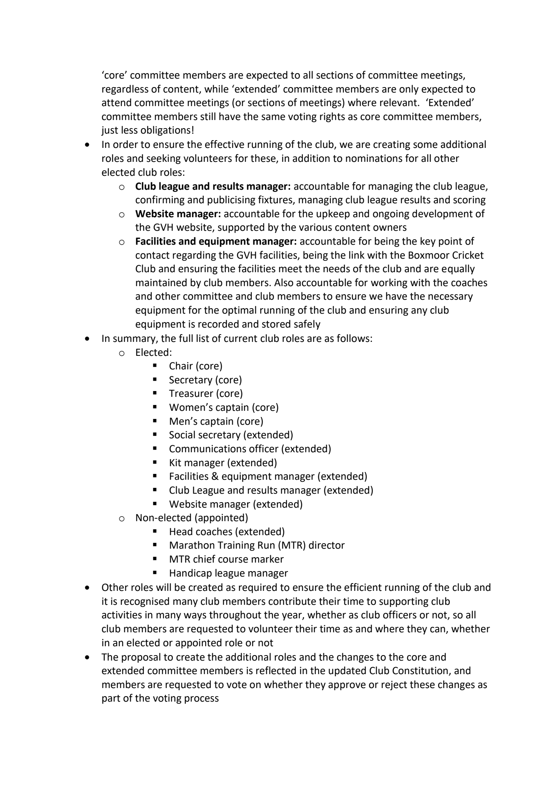

Online voting
We are trialling online voting as part of this year's AGM and have proposed it in changes to the constitution. It is more confidential, easier to audit if needed, easier to manage and we have introduced advanced voting for the club members award and for the GVH nominated charity. Members who have not voted online will still be able to vote in person at the AGM - but we will only issue voting forms on the night to those who have not voted.

Announcement of charity of the year

Nominated charity of the year – Prostate Cancer

Announcement of 2019-2020 club officer appointments

Votes in and counted and confirming our new GVH committee are:-

Chair – Andy Cook
Secretary – Helen Cook
Treasurer – Steve Newing
Kit – Maria Kenny
Social Secretary – Mary McCluskey
Website – Andy Newing
Club League & MTR – Helen Heathcote
Press secretary – Simon Wallis
Facilities – outstanding to be determined by new committee before next AGM

Q&A

Caron Williams
I would like to formally thank everyone at the club for putting on the learn to run course. So many individuals have given up their own training to work with the group as a whole and with individuals on a 1-1 basis. Not to mention the great support from Gemma and Ed which has been inspiring and thoughtful to new runners’ needs. I know how much every session and cheer means to us all and me especially. Thank you all.

Official business

Best male athlete | Rich Coles
Most improved male athlete | Phil Mercer
Best new male athlete | Michael Linden
Best female athlete | Teresa Reason
Most improved female athlete | Mary McCluskey
Best new female athlete | Isabel Wilson
Multi-sport award | Dean Kidd
Club league male | Phil Mercer
Club league female | Helen Heathcote
Club league age-graded | Teresa Reason
Club handicap | Mary McCluskey
Committee award | Paula Cook
Club members award | Ed Price & Gemma Bitaraf

